DOCUMENT 06 — Empire Architecture v2: Stakeholders, Revenue & Expansion
Visionary Internal · v2.0 · One intelligence, many stakeholders, compounding revenue.

Not five products. ONE SCM intelligence surfaced per role. Expansion is sequenced so each
new stakeholder reuses the previous one's data and loop.

1. The 4-app framework × stakeholders (permanent frame, changing intent)

Stakeholder | Learn | Ask | Practice | Build
K12 student | concept→visual/3D | native-language doubt | adaptive quiz | project/portfolio
Competitive | syllabus-mapped | exam-pattern doubt | timed mock | error-notebook
Teacher | own upskilling | "how do I explain X" | pedagogy checks | lesson/quiz/content
Higher-ed/dept | course module | research doubt | cohort checks | course pack
Parent | child's journey | "is this normal / how help" | n/a | home support activity
Professional | skill module | work-context doubt | scenario challenges | portfolio deliverable
Org/institution | program curriculum | operational query | cohort readiness | playbook/module

2. Expansion roadmap

3. The teacher superpower
Class SCM aggregate = live mastery heatmap (the moat for Phase 3). Teacher Profile is an
SCM variant tracking P(can_explain), not P(mastered).
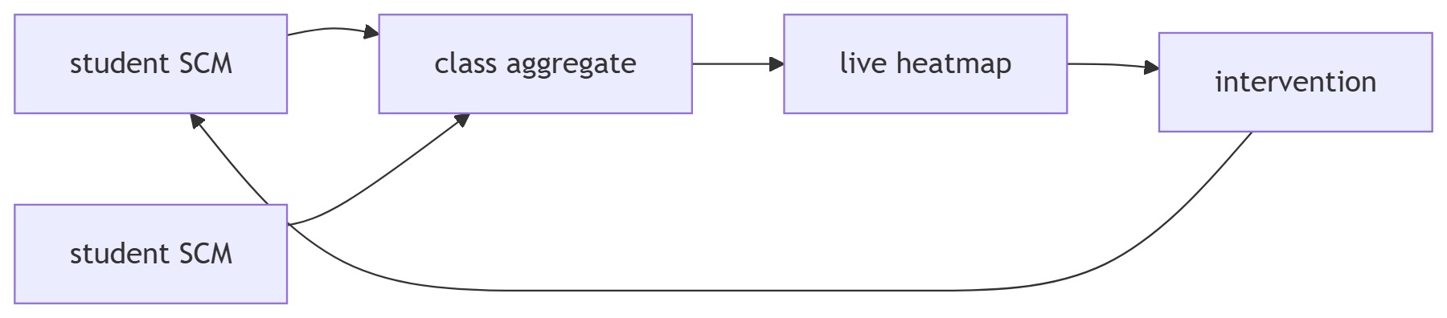

4. Revenue interconnection (the Google-like map)
student success → family plan → parent trust → school license → state contract;
teacher content → marketplace → more content → more students. Each stream lowers the
next one's CAC.

5. Non-negotiables
R1 L7 logging from user #1 · R2 never a wrong fact · R3 SCM from Redis hot path ·
R4 P(mastered) gain = north star · R5 A/B everything · R6 4-app frame permanent ·
R7 dedicated LoRA per stakeholder · R8 runs on Redmi Note 9 / 4G · R9 DPDP by default ·
R10 no autonomous agents.

OKF
KF1: each phase exits only on its gate metric. KF2: teacher heatmap weekly-used ≥60%.
KF3: marketplace opens only after teacher liquidity. KF4: state signs only after school
proofs. KF5: one SCM serves all roles (no parallel cores).

